Oyster Task Force Meeting
Tuesday, February 6, 2024, 10:00am
New Orleans Lakefront Airport
6001 Stars and Stripes Blvd.
New Orleans, LA

I. Pledge of Allegiance
II. Roll call and introduction of guests
Voting Members Present:
Jakov Jurisic
Mitch Jurisich
Brad Robin
Brandt Lafrance
Sam Slavich
Peter Vujnovich
Willie Daisy
Steve Pollock

Voting Members Absent:
Shane Bagala
Tracy Collins
Dan Coulon
Brandon Debarge
Al Sunseri
Matthew Slavich

Non-Voting Members Present:
Robert Caballero
Edward Skena
Brian Lezina

Non-Voting Members Absent:
Kyle Balkum
Harry Vorhoff

III. Peter Vujnovich motioned to approve the December 12, 2023 meeting minutes, 2nd by Brad Robin. Motion carries.

Brad Robin motioned to amend the agenda by adding item K. To Consider Funding a Social Media Promotional Purchase of $2400 for the 2024 Oyster South Symposium, 2nd by Peter Vujnovich. Motion carries.

Brad Robin motioned to approve the February 6, 2024 meeting agenda as amended, 2nd by Peter Vujnovich. Motion carries.

IV. Treasury Report
Fund- $587,662
Budget- $68,050
January Oyster Tag Sales- 157,200

Peter Vujnovich motioned to approve the treasury report as presented, 2nd by Brad Robin Motion carries.

V. Committee Reports:
- Public Private Oyster Seed Grounds Committee- no report
- Enforcement- Edward Skena provided the enforcement report
November 27- January 26th
Region 4 (Iberia)
None
Region 5 (Calcasieu, Cameron, Vermillion)
None
Region 6: (Terrebonne, Lafourche, Grand Isle)
Terrebonne
1- 40:4A Violate sanitation code (No waste bucket)
1-56:424B Failure to have written permission.
1-56:430B(1) Harvest Oysters from unmarked lease.
1-56:424A unlawfully take oysters from state water bottom

Seizures: 16 sacks returned to water
Region 8: (Jefferson, Plaquemines, St. Bernard, Orleans)
St. Bernard
2-RS 56:424 Failure to have Written Permission.
1-RS 40:4A –Violate Sanitation Code (Waste bucket)

Seizures: 34- Full Sacks of Oysters Seized and Returned to water.

Plaquemines
2-RS 40:4A Violate Sanitation Code (Log Book)
2-RS 40:4A Violate Sanitation Code (waste Bucket)
2-RS 56:57.3 Obtain License By Fraud
2-RS 56:305 A- Take commercial Fish without Gear License
Seizures: 186 Sacks Seized and returned to water.
Sam Slavich asked about the unmarked lease case, what are the agents’ instructions when they go out and determine if a lease is marked or unmarked? This lease could have been marked electronically, enforcement stated that a lease would still have to have physical markers even if the lease is electronically marked, Sam Slavich stated that this may be something to consider for a future meeting, would require legislation to make this change. Major Skena stated that this may be an issue when leases are really close to one another, physical markers prevent some of the issues that could arise (no service, leases that are close to one another, etc.)
- Legislative Committee- no report, Jakov Jurisic called for any items needed for legislative session to let him know so the committee can meet

- Legal Committee- no report

- Research Committee- Earl Melancon stated that the task force asked him to look into crop insurance for off-bottom aquaculture and he did; there is crop insurance available for off bottom aquaculture; may consider on bottom traditional oyster insurance at a later time, not considered for this program as 5 years of consecutive production is needed; did not meet those standards

- Coastal Restoration Committee- no report

- Marketing Committee- committee met this morning reviewed some quotes for video snippet projects and marketing costs of these videos, looked at three quotes, will go back and look at the videos the industry already has from LDWF, GOIC and Sea Grant, talked about upcoming marketing opportunities; Jakov Jurisic stated that he tried to reach out to Samantha Carrol with the Seafood Promotion and Marketing Board and will try and reach out again, have not heard anything back as of yet

- Health Committee- Jennifer Armentor provided an update, Steve consider adding a column to the report that will document the location
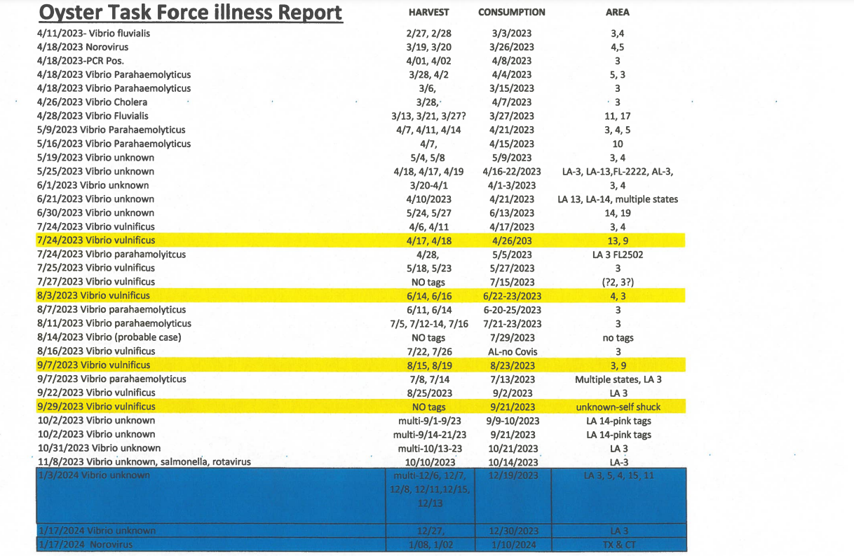

- Aquaculture Committee- preparing a critique and response to the economic analysis of AOC, many farmers reported being profitable putting something together as a response to this and hopefully get a thumbs up recognition that this analysis is just one report, would like this to be an item on the full OTF agenda at the March meeting; Mike Roberts organized a HASSP training certification class February 15 and 16th cost $190 to be certified at the City Park Drive location in Lafitte, LA

- Joint Task Force Working Group- no report
VI. New Business
- Robert Caballero provided the board with an oyster season update

Below is a comprehensive update for the Oyster Season. Daily reporting estimates are up to 2/04/2024 and biologist board run estimates are up 2/02/2024.

Daily Reporting
Below is the table with the daily reporting data. It appears that some of the phone reporting converted over to the eReporting application. Also, the eReporting application has many of the out of state vessel permit users. Total reporting compliance across the state is estimated at 75%, by comparing total harvest vessels observed by biologists versus total vessels complying with daily reporting. Of the 147 vessels daily reporting, 83% are phone reporting and 27% are using the new eReporting app.

Total Vessels Reporting | 147 | 75%
Total Vessels Observed | 195
Total Vessels Phone call | 122 | 83%
Total Vessels eReporting | 39 | 27%

POSG East of Mississippi River and North of MRGO
6,325 sacks reported harvested through daily reporting requirement. Biologist boarding run estimates put the harvest around 10,385 sacks. There is a 39% difference in daily reported harvest versus boarding run harvest estimates for this area. Most of the harvest has taken place In LDH areas 2 & 3, in the northern Biloxi Marsh area. Total harvest for the area has reach 38% of the total Shell Budget thresholds, however two reefs have exceeded the individual reef harvest thresholds. 3-Mile Pass and Shell Point cultch plants have exceed their 50% Fishery Management Plan harvest threshold and Shell Budget harvest thresholds. Closure of these two reefs occurred ½ hour after sunset on 12/03/2023. Harvest in this area has dropped off since the end of December, with only a few boats still participating sporadically. Daily reporting compliance by harvesting vessels is compiled by comparing total harvesting vessels observed by biologists versus total vessels complying with daily reporting. The oyster season compliance estimates so far are at 74% of the vessels reporting and 71% of harvested sacks reported.
POSG East of Mississippi River and South of MRGO
1,990 sacks reported harvested through daily reporting requirement. Biologist boarding run estimates put the harvest around 2,978.5 sacks. There is a 33% difference in daily reported harvest versus boarding run harvest estimates for this area. All of the Harvest for this area is coming from around the clutch plant in Lake Fortuna. Total harvest for the area has reach 21% of the total Shell Budget Thresholds. Daily reporting compliance by harvesting vessels estimates so far are at 80% of the vessels reporting and 70% of harvested sacks reported.

Sister Lake
24,632 sacks reported market oysters harvested through daily reporting requirement. Biologist boarding run estimates put the market harvest around 34,921 sacks. There is a 29.5% difference in daily reported harvest versus boarding run harvest estimates for this area. Most of the harvest came from northern side of the lake and the cultch plants around mid-lake. Sister Lake was open for 20 fishable days and historically is managed through repeated smaller openings. LDH closure lines have extended into Sister Lake, closing some of the more productive northern reefs from November-February. Daily reporting compliance by harvesting vessels for the oyster season averages are at 61% of the vessels reporting and 62% of harvested sacks reported. Market-size oyster levels are good for a re-opening, OTF requested a Lenten season opening, after discussions with CSA Manger of this area, and LDWF is considering an early March second market-harvest opening.

Vermilion/East and West Cote Blanche Bay/Atchafalaya Bay Public Oyster Seed Grounds
While this area is open, no fisherman has been seen during boarding runs or reported harvesting outside of the LDH closure lines. Also, no fishermen have applied for relay permits to access the oyster resource in this area.

Calcasieu Lake (West Cove & East Side)
West cove had 2,166 sacks reported harvested through daily reporting requirement. Biologists boarding run estimate put the harvest around 3,449 sacks. There is a 37% difference in daily reported harvest versus boarding run harvest estimates in this area. Most of the Harvest for this area is coming from the Rabbit Island area. Total harvest for the area has reach 5.1% of the total Shell Budget Thresholds. East side opened January 1st and had 41 sacks reported harvested through daily reporting requirement and biologists boarding run estimates put the harvest around 88 sacks. There is a 53% difference in daily reported harvest versus boarding run harvest estimates in this area. The oyster season reporting compliance estimates so far are at 54% of the vessels reporting and 51% of harvested sacks reported; on days observed by biologists. These percentages are lower than expected due to non-compliance early in the season. There have been several complaints by fishermen in this area including: hook mussel density affecting marketability of oysters, handling/culling time of oysters, and locating oysters within tong-able areas. Some fisherman would like the tonging laws changed to allow hand dredges.

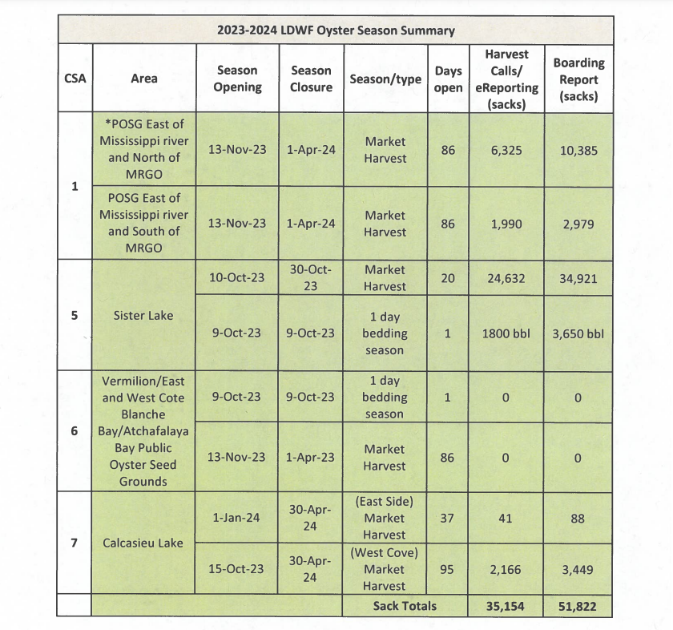
- The Task Force discussed the Oyster Seed Ground Vessel Permit
Major Edward Skena stated no citations issued for on this for this oyster season, but these rules are taking effect now. The Seed Ground Vessel Permit and the Seed Ground Gear permit are tied to the vessel and they are transferrable between resident statuses the only caveat is the fishermen have to be properly licensed according to their resident status.
- Robert Caballero provided some information on a secretarial permit that would authorize the operation of bad-less dredges in West Cove, Calcasieu Lake. Permit pending looking at a pilot study with about 5 fishermen have to be a fishermen in Calcasieu Lake the permit will be associated with a specific vessel will be allowed two bag-less dredges, vessels need to be red flagged, flag must be 12x18” will have to contact LDWF when going out and when returning, this is an effort to knock back the hook mussels. Willie asked for an update in the future on how the program works out, would like the blue crab abundance in the area, Jakov Jurisic suggested prohibiting crabbing in that particular area and see if the crabs can take care of the hook muscle issue
- Item D. to Notify the Task Force of Impending Legislation that Would Prohibit AOC Cages in Unapproved Areas, was deferred to a future meeting
- Dr. Beth Stauffer provided an update on the Lo-Spat oyster project; at the tail end of the first three years of the project set to be a five year contract, last two years $9-$9.5M
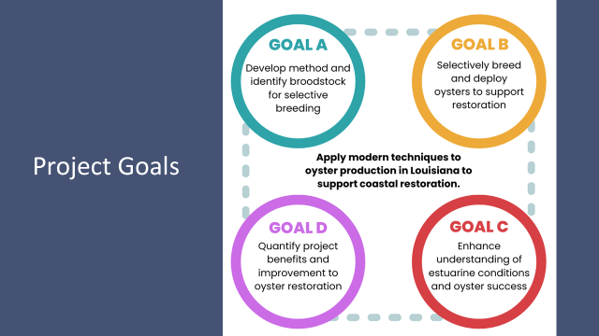
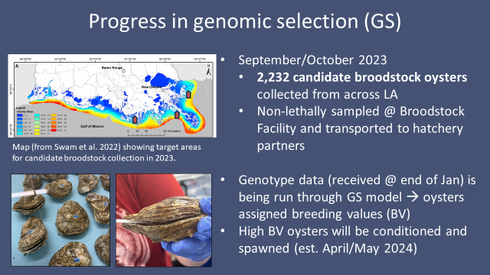
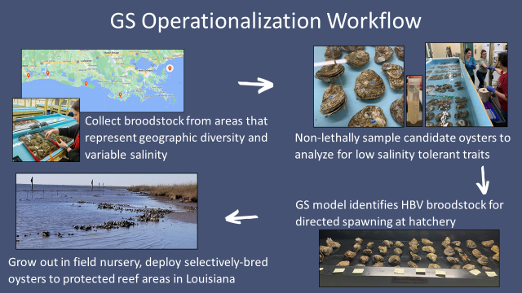
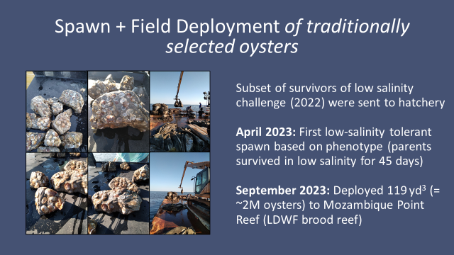
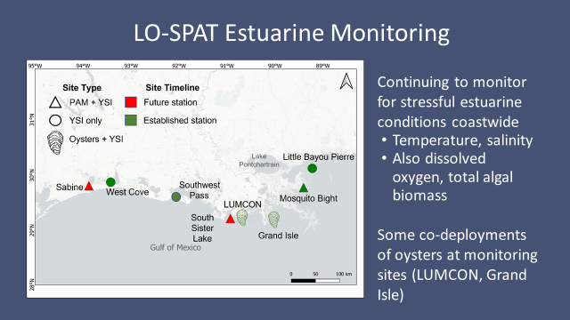
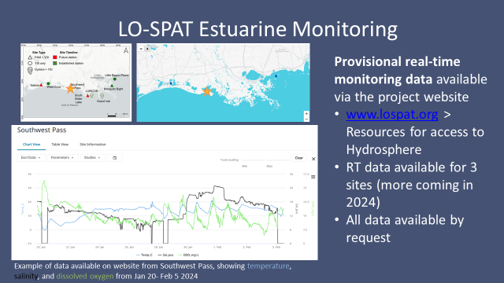
Mitch Jurisich and Brad Robin expressed concern with the amount of funding being spent on this study when the industry is suffering and the money can be put to better use.
- Drayton Agnew led discussion on virus/ bacteria RT-PCR laboratory testing and isolation problems
Official Statement:
Occupation: Louisiana Department of Health Office of Public Health Sanitation Services - Health Inspector inspecting restaurant kitchens, hospitals, schools, daycares, etc.
I received a complaint in January 2023 of someone eating raw oysters from a restaurant on December 1st and having diarrhea for 11-12 days. They were diagnosed with Vibrio and prescribed medication. A coworker and I went to the restaurant where the complainant ate and observed the conditions, refrigeration, and oyster sack tags. Restaurants are required to keep 90 days worth of oyster sack tags in case something needs to be traced. We discard any sacks of oysters that don't have a white tag on them because the sack can't be traced. We destroyed 1 sack because of a missing tag. This could have been handled differently, but it's not the issue.
As a result of my investigation the "raw shellfish consumer warning" wording in the Louisiana Title 51 Code is scheduled to be rewritten to clarify the signage placement. I questioned the lab results asking how genetic material is kept separated in the isolation process and the PCR test. Specifically, how is the vibrio genetic material in the sample kept separate from the genetic material in the culture media? The lab couldn't answer that. Instead the microbiology manager replied saying in 2018 the Louisiana Department of Health lab got a notice saying that sporadic false positives were occurring because the Cary Blair media contains seaweed that was harvested from waters that contain vibrio and the sensitivity of the molecular testing was producing sporadic false positives. After I discovered the Cary Blair media contamination, I asked a series of questions that included "how do I know the case I just investigated isn't based on a false positive?" Or any other case for that matter. I haven't received a reply since then and it's been about 4 months. So, the State Health Department and the laboratory are not able to verify the test results or explain the problems with the contaminated Cary Blair media. What other test results are from contaminated Cary Blair media in Louisiana? In other states?
Louisiana oyster beds and the oyster seasons are affected by Vibrio. The State Health Department should be able to explain and justify their policy and regulation on a scientific basis. If the testing is inaccurate, what downstream effects does that have with regulation and funding? Biofire Diagnostics LLC is the company providing the Cary Blair media, machines, and services that are producing the false positives. In addition to my complaint case problems, there are problems with the isolation method of viruses/bacteria in general by the Louisiana Department of Health. The Louisiana Department of Health Laboratory's isolation method does not make it clear how genetic material from the culture media is kept separate from the genetic material in the suspected sample. It's not clear how a "pure isolate of vibrio from any source" is obtained in the instructions for vibrio confirmation testing by the LDH lab. When the sample is put in the PCR machine, it's not clear the PCR machine is magnifying genetic material from the sample and not genetic material from the culture media that was already there. The material that is detected, it's not clear how long the genetic sequences are compared to the entire genetic sequence of the organism. It's not clear how accurate the genetic sequences are in the computer database of genetic sequences that the results are compared to. Real world example: An independent, certified, private lab owner met with the company Thermofisher to discuss purchasing their PCR products. The lab owner asked similar questions I'm asking. The lab owner decided not to do business with Thermofisher because he discovered the results and materials are not "true isolates" and it's meaningless. Presumption: The Louisiana Department of Health's isolation of viruses/bacteria using culture media and PCR testing is producing insufficient results.
This includes all foodborne illness virus/bacteria testing that uses culture media and PCR testing, as well as all COVID-19 PCR testing. It also includes all infectious disease testing using these methods. This does NOT include chemical contamination testing or drug testing.
Companies selling the Louisiana state government products and services involving these methods need to be investigated for accuracy of results. Government funding and regulation is affected by the testing of foodborne illness and infectious diseases using these methods.
Biofire Diagnostics LLC is the company directly involved in my complaint case.
Here is a list of other companies selling these products and services to the Louisiana state government. You can find them on checkbook.la.gov - Expenditures - Vendor payments:
Biofire Diagnostics LLC, Bio-Rad Laboratories, Biolytical Laboratories, IDEXX Medical Lab, Mako Medical Lab, Orion Laboratories, Randox, Omega Diagnostics, Quest Diagnostics Clinical
Some of these companies only sell these problematic testing methods. Other companies sell many different products and testing services. I'm focused on foodborne illness and infectious disease testing specifically. To be clear, I did not discover something new. I'm listening to experts and applying that knowledge to my specific case. I'm challenging the way things are already being done. I'm not accusing any one person or agency of corruption or any specific crime.

- The task force discussed oyster log book issues; agents checking log books, the logbook lists harvest area OR lease number but it’s being reported that an agent is insisting that both are needed
Edward Skena stated that he interprets the law as either or can be listed on the logbook asked that they get the agents name and the issue can be addressed, no citations were issued in this regard
- Anna Koehl provided an update on the OTF Washington, D.C. trip
It was a great trip, LA Alive event went well, had a lot of promotional items and materials to give out, met with Senator Kennedy, got a meeting with the new LDWF Secretary, got to meet Mike Johnson, speaker of the House
Brad Robin stated that he would like the task force to consider the ‘Let the World be Your Oyster’ event, looking for a venue at this time
Jakov Jurisic stated that the task force met with Senator Cassidy on the way out, Jessica Domangue -Houma state legislator, talked about working together with the new LDWF Secretary
- Jakov Jurisic presented the task force with an oyster video, “The Life Cycle of a Louisiana Oyster’
- The task force considered funding travel for Anna Koehl, Beuerman Miller Fitzgerald
Jakov Jurisic motioned to approve funding travel for Anna Koehl’s (BMF) travel to Washington, D.C. on behalf of the LA Oyster Task Force, 2nd by Brad Robin. Motion carries.
- Task force considered funding for social media advertising for the Oyster South Symposium, which is set for Feb 29-March 2 at the CAC
Brad Robin motioned to approve $2400 in funding for a social media advertising purchase and geo-fencing for the 2024 Oyster South Symposium, 2nd by Sam Slavich. Motion carries.
- The board held officer elections
Brad Robin motioned to nominate Mitch Jurisich as the Chairman of the Oyster Task Force and Peter Vujnovich as the vice-chair, 2nd by Jakov Jurisic. Motion carries.
VII. Public Comment:
George Ricks stated that he has some concerns with the operations of the two diversions, Caernarvan and Davis Pond but mostly Caernarvan, would like to see this task force meet with LDWF Secretary and request that they become more vocal in the operational plan of this diversion, the industry needs to be more vocal in the operational plan as well. This plan does not just impact the oyster industry but shrimp and other industries as well
VIII. Next meeting set for Tuesday, March 19, 2024 for 10:00am at LDWF headquarters
IX. Brad Robin motioned to adjourn the meeting, 2nd by Peter Vujnovich. Motion carries.

